Meet Budapest
Table of Contents
I. Budapest 3
Local government system 3
Population 5
Health care 5
Housing 5
Transport 5
Culture 6
Leisure and recreation 6
Commerce, catering and tourism 8
II. A thousand years of Pest-Buda 9
Prehistoric Period 9
Roman Age 9
The Magyar Conquest 9
Foundation of the Hungarian State 9
The Árpád dynasty 10
The Golden Age of Buda in the 14th to 16th century 10
The Turkish occupation 10
From Pest-Buda to Budapest 10
Millennium 12
Between the two World Wars 13
Centralisation in the 1950's 13
The 1956 uprising 13
Goulash communism 13
The political changeover 13
Table of Pictures 14

I. Budapest
The capital of Hungary is situated along the Danube, in the heart of the Carpathian basin. Hilly Buda, which comprises one-third of the city’s area of 525 km² is located along the right bank of the Danube surrounded by low mountains. János Hill, with its 529 meters is the highest summit of Buda. Across the river sprawls flat Pest. The geology of Budapest has played a determining role in the city’s life over the course of history. Hot springs breaking through limestone mountains supplying water of 35-76 degrees centigrade gave rise to a flourishing culture of spas in the Roman Age and made Budapest one of the most popular spa cities of Europe.
The determining role played by Budapest can be felt not only throughout Hungary but also in the neighbouring countries.
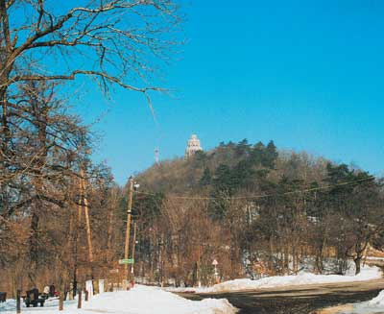
Fig. 1. Janos Hill
The city boasts sites, monuments and spas of worldwide renown. Its numerous cultural events attract a wide international audience. In recent years the UNESCO put several parts of the city on the list of World Heritage.
A large number of the Budapest tourist sites are concentrated along the banks of the Danube. In the southern downtown area that was once surrounded by walls are located the oldest historical monuments of Pest as well as the capital’s financial and cultural centre. North downtown hosts the government or administrative quarters with the Parliament Building, the Offices of MPs as well as a lot of the ministries. The majority of the buildings are turn-of-the-last-century. The most outstanding of the avenues starting from the Danube is Andrássy Avenue bordered by mansions known as palaces carefully designed and erected in the 1870’s, similar to the famous avenues of Paris or the Ring in Vienna.
Two centres emerged on the Buda side. One is the mediaeval Castle District, home of the rulers of Hungary of old, and then assumed government functions until the end of the Second World War. The Buda Castle currently houses cultural institutions including museums, libraries and theatres.

Local government system
Budapest consists of twenty-three districts. The Hungarian capital city has a peculiar dual self-government system. This means that in addition to the Budapest Municipality, the local government of Budapest, each of the twenty-three districts have their own government, the so-called district governments, with elected mayors and a body of representatives. The General Assembly of Budapest and the district bodies of representatives are equal in terms of their basic rights, with no hierarchic relationship between them. A division of labour has emerged among the autonomous and equal local governments which are in line with duties and responsibilities. Local government tasks are generally implemented by the district governments while tasks stemming from its nationwide scope and related to multiple districts or the city as a whole are undertaken by the Budapest Municipality.
The Budapest General Assembly is the representative body of Budapest. Its sixty-seven members are represented by the Mayor and five Deputy Mayors. The Budapest General Assembly sets up committees from its members to prepare decisions and to organise and check on their implementation. The Budapest General Assembly tends to have meetings on a monthly basis. In 2001 the representatives discussed a total of 532 items on the agenda, passed 2,152 decisions and 89 by-laws.
The Budapest General Assembly is assisted by the Mayor’s Office. The Mayor’s Office is responsible for the preparation and implementation of decisions taken by the General Assembly. The Mayor’s Office is headed by the City Clerk appointed by the General Assembly. There are twenty-eight departments in the Mayor’s Office, each responsible for the coordination of tasks in a particular area.
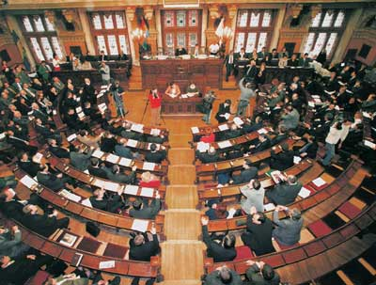
Fig. 2. Assembly Hall
In 2002 the Mayor’s Office was awarded the ISO-9001:2000 Quality Assurance Certificate. This means that in all of its activities the Office follows quality assurance standards accepted throughout Europe.
Age group | Size(number of people) | Percent | Age group | Percent
- 4 | 74,638 | 4.1 | - 19 | 19.7
5 - 9 | 87,742 | 4.8 | - 19 | 19.7
10 - 14 | 91,281 | 5.0 | - 19 | 19.7
15 - 19 | 105,649 | 5.8 | - 19 | 19.7
20 - 24 | 165,134 | 9.1 | 20 - 34 | 24
25 - 29 | 143,368 | 7.9 | 20 - 34 | 24
30 - 34 | 127,685 | 7.0 | 20 - 34 | 24
35 - 39 | 99,407 | 5.5 | 35 - 49 | 20.4
40 - 44 | 117,274 | 6.5 | 35 - 49 | 20.4
45 - 49 | 152,580 | 8.4 | 35 - 49 | 20.4
50 - 54 | 134,158 | 7.4 | 50 - 69 | 23.9
55 - 59 | 120,703 | 6.7 | 50 - 69 | 23.9
60 - 64 | 89,007 | 4.9 | 50 - 69 | 23.9
65 - 69 | 87,903 | 4.9 | 50 - 69 | 23.9
70 - 74 | 83,789 | 4.6 | 70 - | 11.8
75 - 79 | 68,289 | 3.8 | 70 - | 11.8
80 - 84 | 31,222 | 1.7 | 70 - | 11.8
85 - 89 | 23,671 | 1.3 | 70 - | 11.8
90 - | 8,052 | 0.4 | 70 - | 11.8
Total: | 1,811,552 | 100 |  | 100
Table 1. The population of Budapest by age groups in 2000
Source: Central Statistics Office

Population
In 2001 the population of Budapest was 1.774 million, 17% of the country’s population. Women contribute more than half, 54% of the population.

Health care
The number of hospital beds per ten thousand people is 124. The average length of stay in health care institutions is 9.4 per year. The level of use of hospital beds is 88.6%. A family practitioner has an average of 1,323 patients. The national government as well as the city leaders are well aware of the numerous problems that have yet to be solved in health care despite continuous capital investment. The ongoing reform and pending European integration are expected to bring about a major positive change in health care in a few years.

Housing
According to the latest data, there are almost 801,000 dwellings in Budapest. Willingness to build has been on the rise since 1997. In 2001 a total of 11,128 new residential properties were built, 22% more than in the previous year. Most of the newly built residential properties have three or more rooms and an average floor area of 101.5 square metres. Ten percent of residential properties are managed by local governments.

Transport
Public transport in Budapest is the responsibility of the Budapest Transport Company, or BKV by its Hungarian acronym. Between 1991 and 2001 the Budapest Municipality spent 35% of its revenues, 100 billion forints (4.2 billion euros) on transport development. Fifty-nine percent of the Budapest people use public transport to go to work; 29% drive a car and 11% walk. Forty-two percent of the people of Budapest use public transportation day by day and 73% at least once a week.
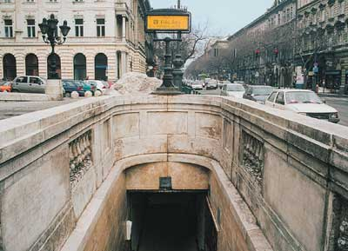 | 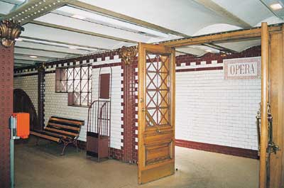
Fig. 3. Millenium Underground
The total length of paved roads in the capital city is 3,353 kilometres. In recent years, fourteen kilometres were added to the road network.

Culture
The city leaders consider it their fundamental task to make Budapest a liveable and pleasant city. A place where local people and visitors can find a variety of leisure activities and entertainment. In recent years the lively café life that had characterised Budapest in the early 20th century has also been rekindled. Walking around the city, visitors are lured by a multitude of cafés and restaurants with terraces, particularly in the increasing number of pedestrian zones. A favoured entertainment area is Liszt Ferenc Square and its vicinity, and recently renewed Ráday Street.
The cultural life of Budapest would be inconceivable without buoyant nights in the theatre. Many of the renowned old theatres have been remodelled over the past few years including the Operetta Theatre and Thalia Theatre. In 2002 the National Theatre, demolished in the 1960’s, was rebuilt on a new site.
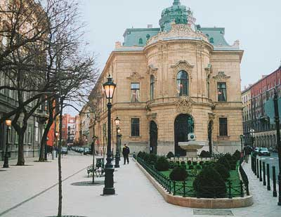
Fig. 4. Szabó Ervin Library
“Szabó Ervin” Central Public Library had also undergone spectacular renewal and expansion which was accomplished in 2001, making it one of the largest and most moderns public libraries in Central Europe. Renewal of the network of branches has also been started recently.

Leisure and recreation
Parks and green areas are the most popular places of recreation. Of the total area of Budapest 13.4% is forest and 2.3% is parks. The Budapest Environmental Protection Programme envisions increasing the proportion of forests to at least 16%, and of parks to 5.5% in the next five years.
Margitsziget, or Margaret Island is one of the most popular places of recreation. From spring to autumn, hundreds of people visit the island to find rest or active recreation among its trees and bushes. Surrounded by the Danube, the island’s 5.3 kilometres circumference is eminently suitable for running, jogging or cycling.
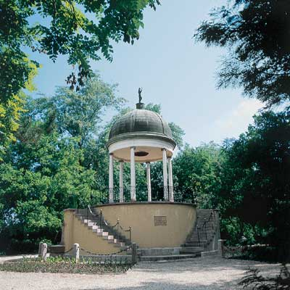
Fig. 5. Margaret Island
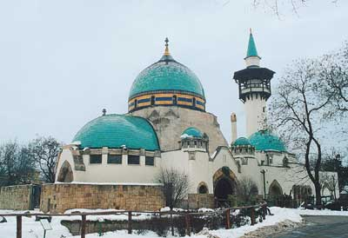
Fig. 6. Elephant House
The City Park on the Pest side hosts several major events every year. Created originally to serve as a site for the Millennium Celebration in 1896, the park near downtown Budapest offers entertainment to local people and visitors alike with its monuments, ponds, outdoor restaurants and cafés. Its lanes and alleys and open spaces are also favoured by sport lovers: cyclists, roller skaters and joggers.
The Zoo is a favourite place of entertainment of both locals and visitors. Boasting many buildings preserved as monuments, the Budapest Zoo launched a major reconstruction project in the mid-1990 which has been going on to date. As a result, the old buildings regained their original splendour and the number of visitors has been continuously increasing. The designers pay special attention to providing an appropriate environment to both animals and plants while preserving the constructed environment evoking the atmosphere of the first decade of the 20th century and considered today as part of our national heritage.
The Amusement Park next to the Zoo is visited by about a million people each year. One of the most visited entertainment facilities, the Amusement Park has seen several major renewals over the past two years resulting in the installation of several new rides. At the same time the Amusement Park does not neglect its old rides nor the numerous facilities considered to be monuments under protection.

Commerce, catering and tourism
In 2001 there was an 110 percent increase in the number of businesses in Budapest. Recent years have brought massive foreign investments in the Hungarian capital. Shopping malls and office blocks have mushroomed. The unique features and ambiance of Budapest make the city a favoured destination for both European and overseas tourists.
Tourism in Budapest has been steadily rising over the past years. Commercial accommodation was sought by two million visitors in 2001 spending a total of 5.1 million nights. The number of foreign visitors was 1.6 million, 55% of whom came from European Union member countries. Lat year the largest number of visitors arrived from Germany, Italy, the United States, the United Kingdom, Israel, France and Austria.
Budapest has become a popular destination for conference tourism over the past few years. In addition to the Budapest Convention Centre built specifically for this purpose, there are countless facilities which are capable of housing even the largest events.

II. A thousand years of Pest-Buda
Budapest is one of the “youngest” capitals in Europe. Although the history of Pest, Buda and Old Buda, or Óbuda, look back upon a thousand years, it was not until the second half of the 19th century that the originally independent three cities were united. The three cities grew into one as a result of natural development, which was sanctioned by the official merger in 1873. Since then, dwellers have become the people of Budapest with a gradually emerging “metropolitan identity”.

Prehistoric Period
The limestone caves in the Buda Hills were discovered by cave men, who used them as shelter. The foot of the hills served as a convenient crossing across the Danube for the inhabitants of primitive settlements in the region as early as the 9th century B.C. Archaeological finds revealed a developed society in urban communities established by the Celts several hundred years later.

Roman Age
Roman conquerors first appeared in the region in the mid of the 2nd century B.C. The Danube was the natural limes, or border, of Pannonia Province of the Roman Empire. Military camps protecting the empire were built at the sites of fords and civilian towns sprang close by. One of the most important civilian towns was Aquincum in the present-day territory of Óbuda. People built stone houses and baths; an amphitheatre served for their entertainment and their safety was ensured by the Roman legions.
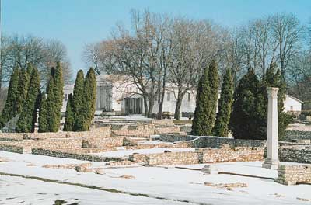
Fig. 7. Aquincum

The Magyar Conquest
Magyar tribes advancing from the east occupied the Carpathian basin in the late 9th century A.D. Headed by Árpád, the leading tribe which gave the first dynasty of Hungarian kings chose Aquincum as their settlement in the natural centre of the land. Prince Árpád the Settler was buried near the ruins of the old Roman town in 907.

Foundation of the Hungarian State
The section of the Danube at present-day Budapest was used as a ford as early as the 10th century. A sad reminder of this era is Gellért Hill on the river bank, named after Bishop Gellért, tutor of Prince Emery, son of King Stephen I (St Stephen), founder of the Hungarian State, who was captured by revolting pagan Hungarians when on his way across the river from the Pest side, and was cast into the Danube from the top of Kelen Hill (today’s Gellért Hill).

The Árpád dynasty
In the mid-13th century the security of Europe including Hungary was threatened by nomadic tribes from Asia. The Mongol hordes first devastated the town of Pest, and then in the winter of 1241-1242 crossed the ice of the frozen-over Danube to burn down Buda. Some of the population fled, a large part perished under the attack. Once the Mongol invasion was over but the threat of a new attack pending, King Béla IV (1206-1270) ordered a fortified castle to be built on the Buda Castle Hill. The town was surrounded by walls and some of the population of Pest was moved within the walls.
Rabbits Island in the middle of the Danube, today’s Margaret Island or Margitsziget was used as hunting grounds for the King. He vowed that he would found a Dominican Convent after the retreat of the Mongol hordes and he would enrol his daughter, Princess Margaret to live there as a nun. Indeed, Princess Margaret, later canonised Saint Margaret, never left the convent on the island.

The Golden Age of Buda in the 14th to 16th century
The two cities reached their heydays during in Middle Ages, during the reign of King Matthias. Chronicles have it that Matthias Hunyadi was crowned king on the ice of the Danube by public acclaim. His Italian wife, Queen Beatrice brought humanist scientists and Renaissance culture into the Hungarian royal court. King Matthias commissioned paintings by the most renowned artists of the period. An enlightened and cultured ruler, he created Bibliotheca Corviniana, a library of two thousand illuminated manuscripts, second only to the Vatican Library of the time. Some of the manuscripts are on display in the Buda Castle.

The Turkish occupation
The Turks occupied Buda in 1541 and held it until 1686. The sultan, Soliman I (the Great) set up Buda as the seat of one of the Turkish provinces governed by a pasha. For the Turkish Empire, Buda was the key to the west, a place of strategic importance.
The two cities sprang different cultures and lifestyles. Churches were transformed into Mohammedan mosques, twelve in Buda and four in Pest, to serve the faith of the rulers. Social life centred around the baths. Hence the proliferation of Turkish baths on the Buda side, some of which are still in operation. The culture of Turkish baths lay the basis for ht character of Budapest as a spa city, which emerged by the 19th century.

From Pest-Buda to Budapest
The Classicist architectural style of Pest emerged in the 17th century whereas Buda was dominated by Baroque buildings. The metropolitan image of Pest, characteristic to date, was shaped after the devastation of the great floods in 1838.
Dynamically developing during the Austro-Hungarian Monarchy, Pest emerged as the centre of the country in every respect by the mid-19th century. The population soared, trade and banking boomed, mansions and hotels mushroomed, cultural life was buoyant. Still, an overarching programme embracing all areas of modernisation was needed. This programme was created by statesman Count István Széchenyi (1791-1860). His firs major claim to fame was the initiative to build Chain Bridge, the first permanent bridge over the Danube connecting Buda and Pest, which was commissioned in November 1849. Besides the Chain Bridge, a number of public buildings are also connected to Széchenyi’s commitment to development and modernisation including the Hungarian Academy of Science, the old National Theatre and the Tunnel at the head of Chain Bridge. He initiated river control and introduced steam boats as well as horse racing.
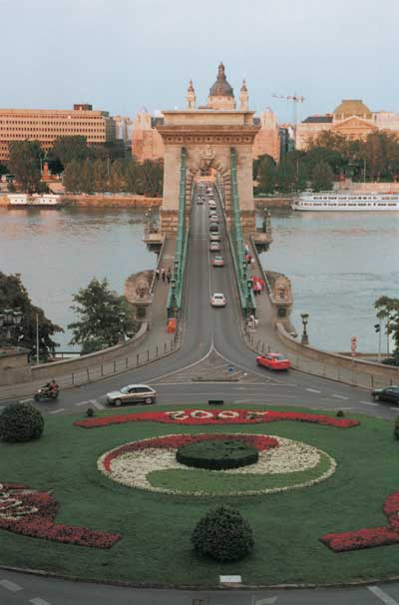
Fig. 8. The Chain Bridge
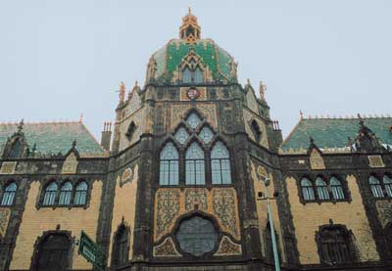
Fig. 9. Museum of Applied Arts
The unification of Buda, Pest and Old Buda was a ceremonial occasion in 1873. Since then, the city has been a permanent building site. The streets of Pest were widened, lengthened and generally upgraded on a massive scale on the basis of carefully conceived concepts of urban planning. Construction of Andrássy Avenue started in 1871 and in the same year a statute was enacted on the construction of the Nagykörút, the Grand Boulevards of Budapest. Margit Bridge, the second bridge over the Danube was erected.
Art Nouveau had lots of followers in Hungary. Its most prominent cultivator was Ödön Lechner, architect of the Museum of Applied Arts.
Public transport started to develop in the mid-19th century. Horse-drawn transported passengers between Kálvin Square downtown and emerging suburb of New Pest, and between Chain Bridge and Old Buda. The ancestor of today’s tramway was commissioned in 1887 along the Nagykörút. The funicular railway to Castle Hill was built in 1870 followed by the cogwheel railway to Szabadság Hill four years later. Important sites of bourgeois social life proliferated: cafés including the famous literary cafés New York, Centrál and the Japanese Café. In 1884 the Hungarian Opera House was erected according to the design of Miklós Ybl.
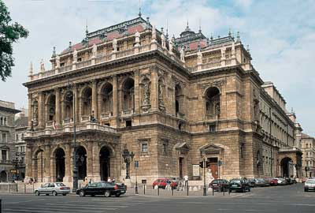 | 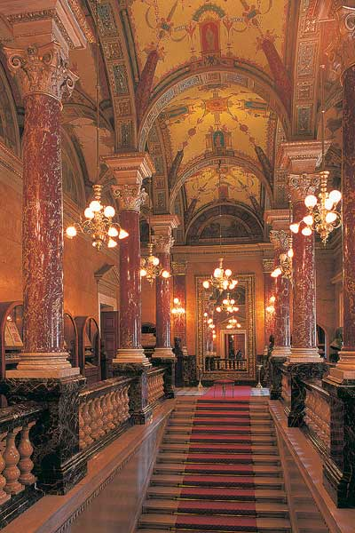
Fig. 10. The Opera House

Millennium
The era was crowned by the Millennium in 1896, celebration of the 1000th anniversary of the settlement of the Hungarian tribes in the Carpathian Basin. A nationwide exhibition commemorated the event. The buildings housing the Budapest exhibitions were erected in the City Park. Hungary’s agriculture, industry and trade were displayed, as were the Hungarian culture, countryside and towns. The first underground railway in continental Europe was inaugurated in the year of the Millennium Celebrations. After almost twenty years of construction, the Neogothic building of the Hungarian Parliament was accomplished in 1902.
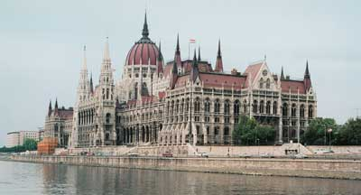
Fig. 11. The Parliament

Between the two World Wars
As a consequence of the Treaty of Trianon after World War I, Hungary lost two-thirds of its territory. Shattering the country to its very foundations, the peace settlement led to a further strengthening of Budapest’s political weight and role. By the 1930’s a conurbation took shape around Budapest whose villages were tied to the capital by a thousand threads.
The city leaders were impotent in the face of the turbulent events of World War II. They remained inactive during the terror of the Hungarian fascist regime and stood by while a mass of its population was carted away. Budapest lived through the mindless destruction of World War II as one of the most suffered and devastated cities.

Centralisation in the 1950's
Built along the Soviet model, the system of councils introduced in 1950 meant a break with democratic traditions. Centralised city leadership left no room for the implementation of local interests. With the addition of suburbia and adjacent villages, the originally ten districts created at the time of the unification grew to 22 by 1950.

The 1956 uprising
In the autumn of 1956 Budapest became the city of revolution. What started as a student demonstration on 23 October snowballed into a mass protest against communist dictatorship. The first day of the uprising ended in a shootout at night at the headquarters of the Hungarian Radio. Lasted only a few days, the victorious uprising set out to restore Hungary’s previous democratic system and independence with Prime Minister Imre Nagy at the helm. The overpowering Soviet military, however, suppressed the Hungarian uprising.

Goulash communism
In an effort to ease tension after the reprisals that followed the lost revolution the new political leaders of the country had to pay more attention to people’s living conditions. A programme was started in order to solve housing problems, giving rise to huge uniform housing estates all over the country. Welfare measures alleviated people’s existential problems. Budapest became the shop window of communism in the “merriest barrack” of the communist block. Budapest continued to be the centre of power, where all the central organs of state administration and the communist party were headquartered.

The political changeover
Dictatorship slackened by the 1980’s and an underground dissident movement was active, dodging harassment and retributions. Domestic and foreign political events undermined the alertness of the government by the late 80’s and the Soviet Union had also weakened. A huge demonstration was organised in the streets of Budapest in 1989 on the occasion of the reburial with honours of the martyrs of 1956. It was obvious by then that the communist power had to yield to the forces urging democratic changes. After the proclamation of the Third Republic the general elections were followed by local elections in the autumn of 1990. Gábor Demszky, the young liberal politician and renowned dissident underground publisher was elected mayor of Budapest. The young city leaders had to tackle the immense job of dismantling Soviet military barracks and statues of labour movement activists, not to mention the renewal of buildings in a bad state of repair and rundown infrastructure, and the reconstruction of lost or destroyed monuments. The new city builders continued in the footsteps of their forefathers of a hundred years earlier.

Table of Pictures
Fig. 1. Janos Hill 3
Fig. 2. Assembly Hall 4
Fig. 3. Millenium Underground 6
Fig. 4. Szabó Ervin Library 6
Fig. 5. Margaret Island 7
Fig. 6. Elephant House 7
Fig. 7. Aquincum 9
Fig. 8. The Chain Bridge 11
Fig. 9. Museum of Applied Arts 11
Fig. 10. The Opera House 12
Fig. 11. The Parliament 12

